**Experiment – 11**

**PROCEDURES**

**Aim:**

* Create a table with attributes students and marks.
* Insert values into the table.
* Create a procedure to get the merit students (marks > 50).
* Create a procedure to get marks of a given id (using in).
* Create a procedure to display highest marks (using out).
* Create a procedure to get marks of a given id (using in and out).

**Components:**

* + A procedures or function is a group or set of SQL and PL/SQL statements that perform a specific task.

**CODE WITH OUTPUT**

* Create a table with attributes students and marks.
* Insert values into the table.
* Create a procedure to get the merit students (marks > 50).

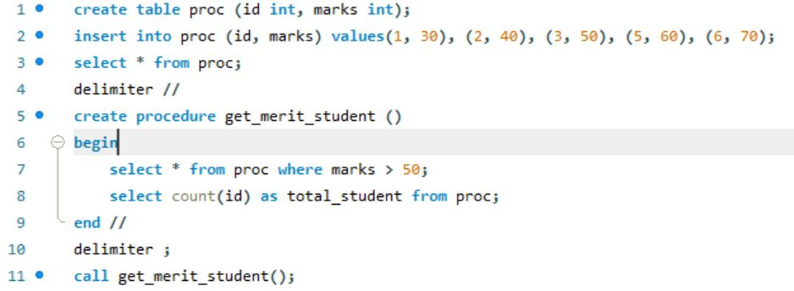

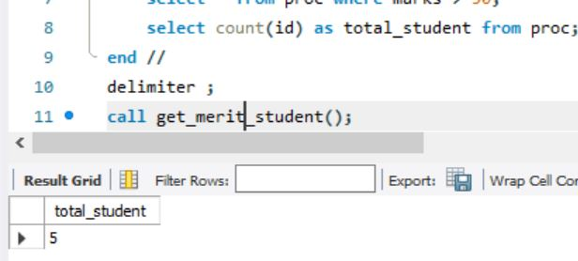

* Create a procedure to get marks of a given id (using in).

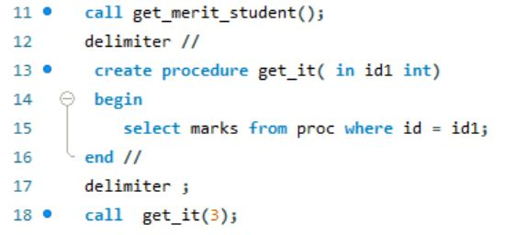

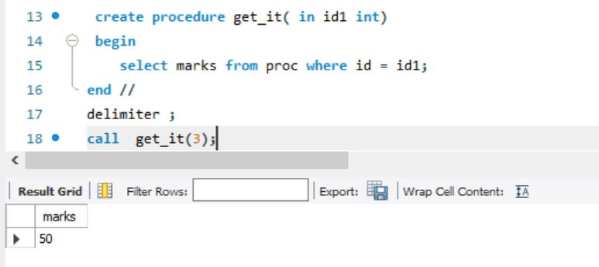

* Create a procedure to display highest marks (using out).

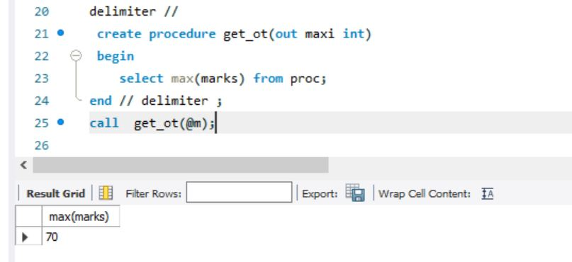

* Create a procedure to get marks of a given id (using in and out).

